Week 3 – Hardware Development Update

Document Version Number: 1.0

Date: March 14th

Author: Yu Chen Xu

Software Version: 1.0

Hardware Version: 2.0

Goal: To explain the updated version of physical model.

Contents

Loading system 2

Ball resting zone 3

Light sensor position 3

# Loading system

A loading system is now implemented from the past week.

**Before**

**After**

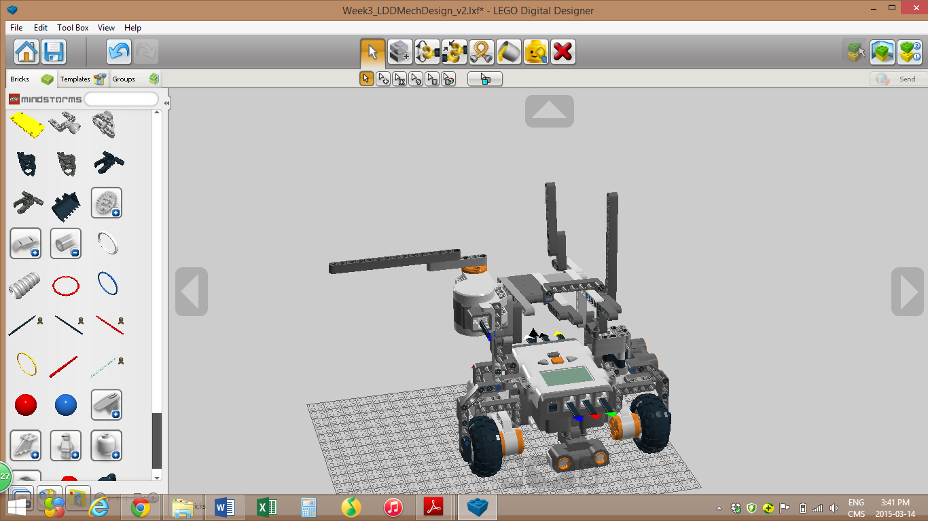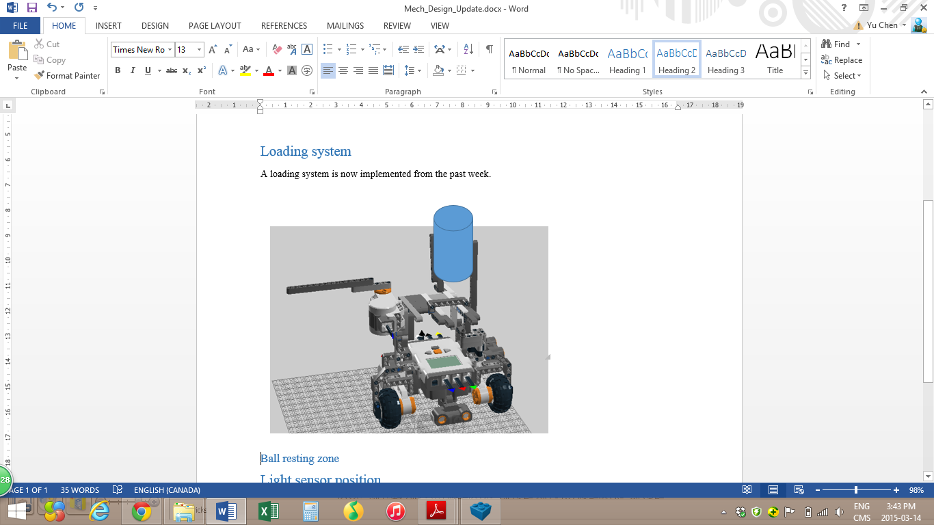

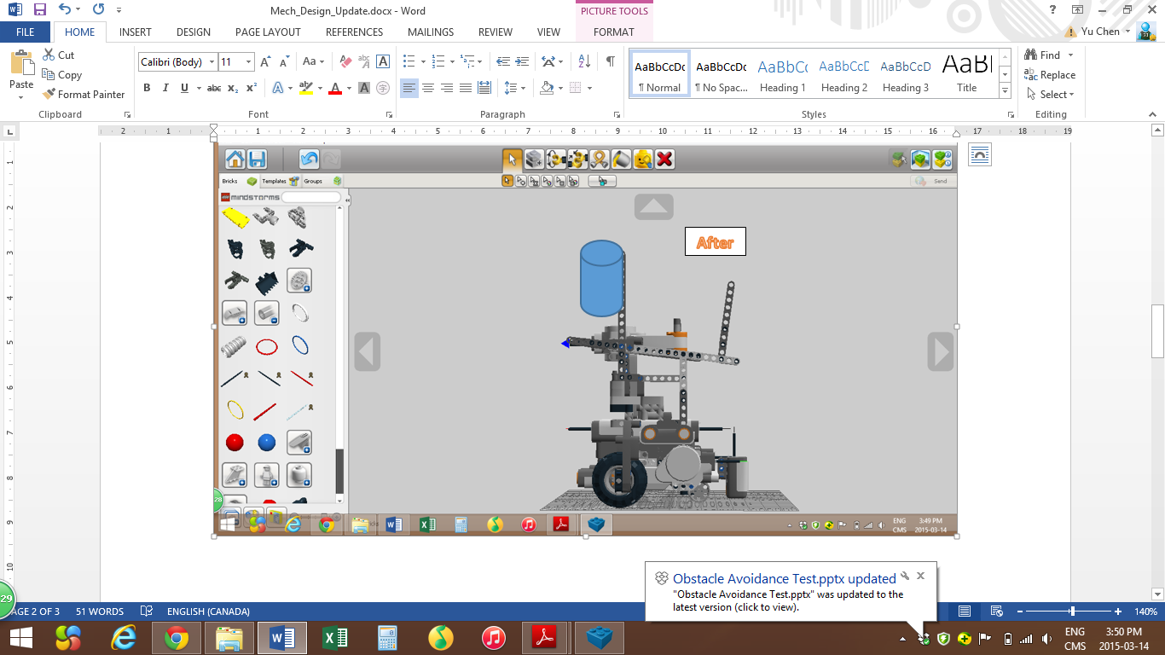

As shown from the pictures, a cylindrical toilet paper tube will be added. This tube will be attached to a stick with a rubber band.

## Ball resting zone

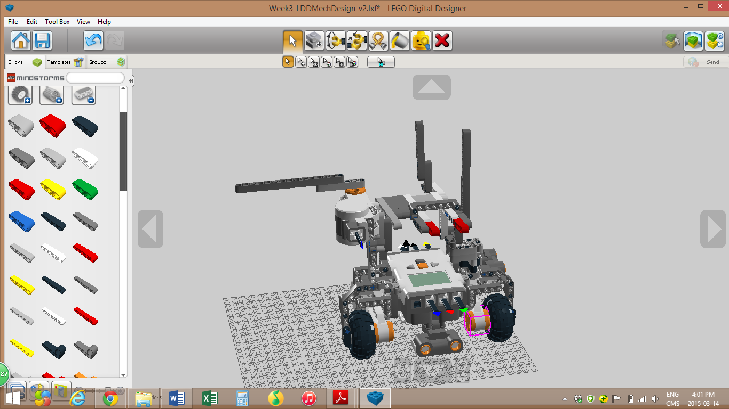

As shown on the picture, two additional sticks, in red, have been attached. The purpose of this addition is to secure the ping pong ball resting zone, preventing it from falling off when another ball is loading.

# Light sensor position

The light sensor will be moved up by approximately 1cm, to make sure that it won’t be scratched by the ground.